Kady Bird & Matthew Miller: Team 16

Professor Batarseh

CDS301-001

26 November 2018

**Part 2: Development Project Screenshots**

Link to the DHHS Breach Portal Reporting Tool dataset: <https://ocrportal.hhs.gov/ocr/breach/breach_report.jsf>

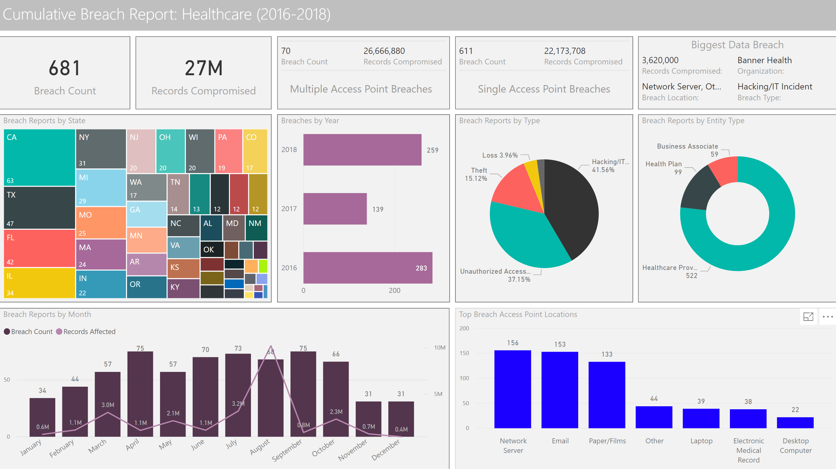

Link to the different UNSW-NB15 Datasets used to make this dashboard: <https://www.unsw.adfa.edu.au/unsw-canberra-cyber/cybersecurity/ADFA-NB15-Datasets/>

